Manual Testing

A set of program to take input and process to perform process and to get output.

Software application Vs Software Product:

A software developed depending on specific requirement of customer is call software application. Customer is the owner of the software application and they are providing development changes to the developing org.

Software developed depending on overall market requirement is called software product. Developing company is the owner of the software product .interested customer are purchasing license of the product.

Software Bidding: It indicate proposal of new software development.in a software application development .The proposal coming from the developer.in cae of product proposal coming from the company it self.

Kick up Meeting: After getting proposal from the developer CEO of org. select person as PM by conducting meeting call kick up meeting

PIN Document: A project maneger is preparing a rough plan interm of required no. of software engg, expected time to complete reuired technology to complete etc .Pm will sumbit this doc to CEO for review to decide whether the new project development is possible or not if possible the company follow the SDLC

Introduction:
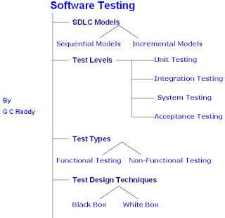

I) SDLC Models
As Software Tester you must have exposure on Software Development Life Cycle / Software Development Process. Actually it is developers /Programmers concern, but Testing also part of SDLC, so you need to concentrate on SDLC process.
In the IT industry there are several SDLC models available, but we can segregate them in two categories.
a) Sequential Development Models

b) Incremental / Iterative Models
You must familiar with at least two Sequential Development Models and two Incremental / Iterative Models in order to get better opportunities.
Sequential Development Models:
In this Approach Software Project development is divided into phases like Requirements gathering, Analysis & Planning, Design, Coding, Testing and Release & Maintenance, every stage output is input for next stage.
Easy way of development, takes less time, but success not guaranty, recommendable for small scale, low budget and short term projects.
Ex: Waterfall Model, V model etc…
Incremental / Iterative Models:
In this approach, the first increment is often a core product. The core product is used by the customer or undergoes a detailed review. As a result of use and/or evaluation a plan is developed for the next increment. The plan addresses the modification to the core product to better meet the needs of the customer and delivery of additional features and functionality.
Software is constructed in a step-by-step manner. While a software product is being developed, each step adds to what has already been completed.
Advantages of Incremental Model
o System is developed and delivered in increments after establishing an overall architecture.
o Requirements and specifications for each increment may be developed.
o Users may experiment with delivered increments while others are being developed.
o Intended to combine some of the advantages of prototyping but with a more manageable process and better system structure.
o Incremental development is especially useful when staffing us unavailable for a complete implementation by the business deadline.
o Early increments can be implemented with fewer people.
Examples: Spiral Model, Agile Models etc…
II) Test Levels
This is Tester’s first and direct concept, we have 4 levels of testing for every software project, some may have 5 levels of testing.
Generally 4 levels of testing is common for every software, but 5 levels of testing for distributed (Business Integration) software.
Test Levels for Independent Applications (No business dependency with other Applications)
a) Unit / Component / Program / Module Testing
b) Integration Testing
c) System Testing
d) Acceptance Testing
Test Levels for Integrated Applications (Business dependency with other Applications)
a) Unit / Component / Program / Module Testing
b) Component Integration Testing
c) System Testing
d) System Integration Testing
e) Acceptance Testing
Unit / Component Testing:
The testing of individual software units or components.
In this level usually developers conduct Testing using White box test techniques like Statement testing, condition testing, Decision testing etc... techniques.
Integration Testing
Testing performed to expose defects in the interfaces and in the interactions between integrated components or systems.
System Testing
The process of testing an integrated system to verify that it meets specified requirements.
In this level usually Independent Testers conduct Testing (Functional and Non-Functional) using Black box test design techniques like Equivalent classes, Boundary Value Analysis, Decision Tables, State Transition Testing etc... Techniques.
Acceptance Testing
Formal testing with respect to user needs, requirements, and business processes conducted to determine whether or not a system satisfies the acceptance criteria and to enable the user, customers or other authorized entity to determine whether or not to accept the system.
3 type of Acceptance Testing
a) User Acceptance Testing
End users / Customer representatives perform this type of testing based on Business Requirements
b) Operational Acceptance Testing
Network administrators/ Technical support people conduct this type of testing
c) Certification Acceptance Testing
Certified Testers conduct this type of testing
-----------------------------------------------------------------------------
I-Tier Application Architecture

Software Environment:
It Consists of Presentation Layer, Processing Layer and Data Storage Layer
Overview on 1-tier application:
1-Tier or Stand-alone or desktop Applications having only one layer, presentation and processing layers both reside in the same Layer.
No Data Storage Layer, Data will be stored using File format on Hard Disk Drive or any other secondary storage drives like Floppy or USB drive etc…
Data has 2 types of format, one is File format another is Table format. Table format is powerful and useful format.
Examples for I-Tier or Stand-alone Applications:
Notepad, Word pad, MS Word, MS Excel, Acrobat Reader, Winzip, WinRar, QTP tool Etc...

II-Tier Application Architecture
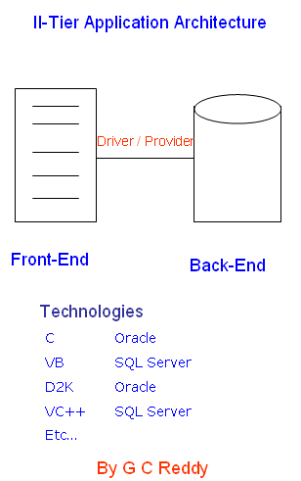
III-Tier Application Architecture

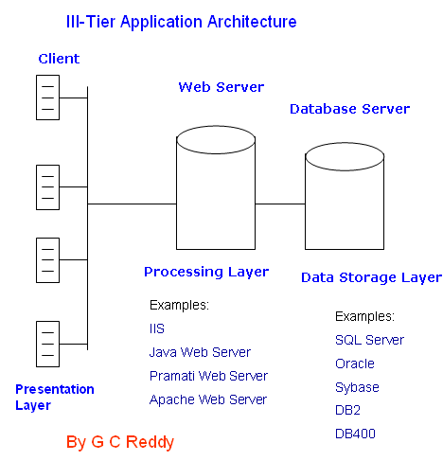

N-Tier Application Architecture

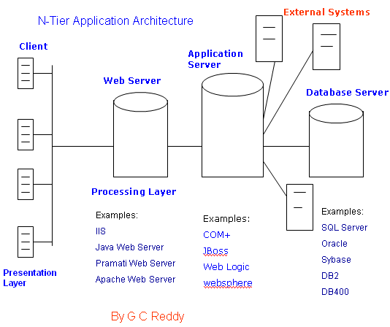

Software Development Life Cycle
I) Requirements Gathering (BA/BT)
in case of customer specific application:
-----------------------------------------
Business Analyst category people gathers requirements from the customer, and prepares
BRS (Business Requirement specification) and submits to Project Manager.
PM sends BRS for review, after getting review report and clarifications, PM approve the document.
Document stages:
a)document creation/preparation
b)document review
c)document approval
Base lined document (finalized)
------------------
we can execute this base lined document
in case of Software Product:
----------------------------
Business Team gathers requirements from model customers and explores competitor products, and prepares
PRD (Product Requirement Document) and submits to Project Manager.
PM sends PRD for review, after getting review report and clarifications, PM approve the document.
------------------------
Output of this stage:
---------------------
Baselined BRS/PRD
Document names may vary from one company to another
Ex: BRS/CRS/BRD/URS/PRD etc..
----------------------------
II) Analysis & Planning (Tech Manager and Project Manager)
------------------------------------------------------
Technical Manager analyzes BRS document in terms of below factors
a) are they complete requirements?
b) are they correct requirements?
c) are they achievable requirements?
d) are they Testable requirements?
------------------------
after analyzing the above factors Technical Manager creates SRS (Software Requirements specification) Document
SRS consists of two sub documents
a) FRS (functional requirement specification)
FRS describes functionalities to be developed
b) SRS (System Requirements specification)
SRS describes Software & Hardware to be used
---------------------------
During SRS creation TM concentrates on Technology selection
He considers below factors for selecting Technology:
Technical factors:
------------------
a) Nature of the Application
b) Organization's experience
---------
Business factors:
----------------
a) Cost/Budjet
b) Customer interests
--------------------------
Planning:
---------
Project manager analyzes risks, creates project plan, team formation etc...
-------------------------------
Output:
-------
SRS
Project Plan
III) Design (System Arch)
--------------------
Input: SRS
------
System Architect / senior developer creates Software Design document(SDD)
It consists of two types of design docs
a) HLD (High Level Design) or Global Design
Overall architecture of the system
b) LLDs (Low Level design) or Detailed Design
Internal architecture of each and every Unit/component/module
Note: System Architect uses either word document or UML like tools for Software
-----------------------------------------------
Output:
-------
SDD
IV) Implementation / Coding (Developers/programmers)
----------------------------------------------
Input:
SDD
Developer/Programmers develop the code based on Design documents and they follow
coding standards
Output:
-------
Code documents
software(.exe file)
Testing (Testers)
-----------------
Input:
------
software(.exe file)
SRS
Testers test software based on SRS, if they find any mismatch, send defect reports
, after fixing defects, confirm fixes and close defects
Output:
-------
Tested software
Test documents
V) Release & Maintenance (Release Team/Maintenance Team)
-----------------------------------------------------
Release:
--------
PM forms Release Team, Release team consists of a few developers, testers,project management executive, and system administrator
Release Team goes to customer place and deploys software.
Release Team provides some training to the customer site people (if required)
------------
Maintenance:
------------
PM forms Maintenance Team, Maintenance team consists of a few developers, testers, and project management executive
Release Team receives customer change requests and perform required changes
Maintenance(3 types)
---------------------
a) Modifications
i) Corrective changes
ii) Enhancements
b) Migration
Migrating from old technology to new technology
(ex: windows 98 to Vista/windows 7)
Ms Access to SQL Server/Oracle)
c) Retirement
Retiring the Old system and developing New system
(Ex: II-tier application to web application
Waterfall Development Model
Overview:
Waterfall development model was launched in 1970’s. It is a framework for software development in which development proceeds sequentially through a series of phases, starting with Business requirements, Software Requirements analysis and planning to develop software product, release and maintenance.
In this model each phase has specific deliverables, after completion of a phase/stage next stage will begin. One stage output is input for next stage.
A number of variants of this model exist, with each one quoting slightly different labels for the various stages. In general, however, the model may be considered as having six distinct phases, described below:
a) Requirements Gathering:
This first step is also the most important, because it involves gathering information about what the customer needs and defining, in the clearest possible terms, the problem that the product is expected to solve.
b) System Requirements:
In this phase Business Requirements are converted as Software Requirements.
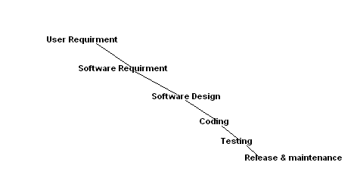
Waterfall Model Diagram
c) Design:
In this phase Global and Detailed design can be produced based on Software Requirements.
d) Coding:
This step consists of actually constructing the product as per the design specification(s) developed in the previous step. Typically, this step is performed by a development team consisting of programmers, interface designers and other specialists, using tools such as compilers, debuggers, interpreters and media editors. The output of this step is one or more product components, built according to a pre-defined coding standard and debugged, tested and integrated to satisfy the system architecture requirements.
e) Testing:
In this stage, System will be tested by testers, if the find any mismatch they report defects. Developers /Programmers fix the defects and then testers close defects by performing confirmation testing (Regression Testing).
f) Release & Maintenance:
Release team (consists of a few developers, testers, and tech-support people etc…) install software in Customer environment and they consider below factors;
Correct & Complete installation
User Management
Services Management
Coexistence with other software
Handling of Input & Output devices
Handling of secondary storage devices
Etc…
Maintenance team process Customer issues based on service agreements.
3 Types of Software maintenance:
a) Modifications
b) Migration
c) Retirement
Advantages of Waterfall Model :
i) Simple and easy to use
ii) Easy to manage due to the rigidity of the model- each phase has specific deliverables and a review process.
iii) Phases are processed and completed one at a time.
iv) Works well for smaller projects where requirements are very well understood.
Disadvantages of Waterfall Model :
i) No working software is produced until late during the life cycle
ii) High amount of risk and uncertainty
iii) Poor model for complex and object oriented projects.
iv) Poor model for Long and ongoing projects
v) Poor Model where requirements are at a moderate to high risk of changing.

V Model
Overview:

A framework to describe the software development life cycle activities from requirements specification to maintenance.
The V-model illustrates how testing activities can be integrated into each phase of the software development life cycle.
V Model was inaugurated in order to avoid drawbacks in Waterfall model and its main focus on multiple stages of testing.
Multiple stages of Testing avoids defects multiplication.

Software Quality:
Quality: Meeting Customer Requirements and expectations.
Software Quality:
Meet Customer Requirements (Functionality)
Meet Customer Expectations (Performance, Usability, portability etc...)
Cost to purchase license
Time to release
Note: First two factors are Technical, last two factors are Non-Technical.
Quality Assurance (QA):
Defining, Monitoring and Optimizing the process is called Quality Assurance, it is part of Quality Management and It is Prevention oriented.
Quality Control (QC)
Checking the System (Final Outcome) with respect to Requirements is called Quality Control and it is Detection oriented.
Verification:
Testing Quality work products (Documentation such as Test Plan, Test Cases Etc...) by performing Reviews and conducting meeting etc... and it is Static
Validation
Testing the Working Software based on its Requirements and it is Dynamic.

Verification Validation

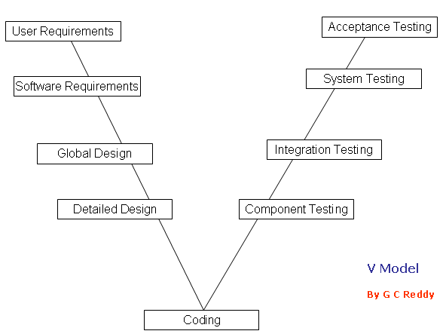

Description of V Model:
It is Verification & Validation model, known as V Model, in this model all development phases can be integrated with Testing phases.
It is considered to be an extension of the Waterfall model. This is because just like the waterfall model, it's a well structured method in which the different phases progress in a sequential or linear way. That means each phase begins only after the completion of the previous phase.
Development Phases Integration with Testing Phases
a) User Requirements Vs Acceptance Testing
Business Analyst category people gather requirements and the document the requirements, after documentation Reviews, Meetings like verifications will take place in order get correct & Complete Requirements.
End Uses derive Acceptance Test cases from User Requirements.
b) Software Requirements Vs System Testing
Development Manager/Tech Manager converts User Requirements as Software Requirements and Reviews, Meetings like verification methods will be performed on Software Requirements, after Verification Project manager provides Approval.
Independent testers generate test cases from Software Requirements in order to perform System Testing
c) Global Design Vs Integration Testing
System Architect / senior developer creates Global design, Informal Review/ Walk through / Technical Review / Inspection like Verification methods will be applied on Design documents.
Developers perform Integration Testing based on Software Global Design.
d) Detailed Design Vs Unit / Component Testing
Developers perform Unit /Component Testing based on Software Detailed Design.
Advantages of V Model:
o Tester role will take place in the requirement phase it self
o Multiple stages of Testing available so that Defects multiplication can be reduced.
o Can be used for any type of requirements
o Due to Multiple stages of Testing and Multiple teams involvement Quality can be improved.
o The V Model Supports wide range of development methodologies such as Structured and Object oriented systems development.
o The V Model supports tailoring.
Disadvantages of V Model:
o It an expensive model than Waterfall model, needs lot of resources, budget and time.
o Co-ordination and Maintenance are difficult.
o Adoption of changes in Requirements and Adding New Requirements at middle of the process are difficult.
o It needs an established process for proper implementation.
Prototype Model

Overview on Prototype Model:
It begins with requirements gathering. Developers and Customers meet and define the overall objectives of the software.
Developers prepare design documents using all available requirements then build the prototypes, prototypes are sent to Customer, and Customer evaluates Prototypes and gives feedback. Developers redefine Requirements, modify software design and produce modified Prototypes. Process will be continued like this, after getting Customer’s confirmation Developers Start Regular process; Software Design, Coding (Implementation), Testing and Release & Maintenance.
The Objective of this approach is getting clear (Complete and Correct)
Requirements from Customers in order to avoid Defects multiplication.

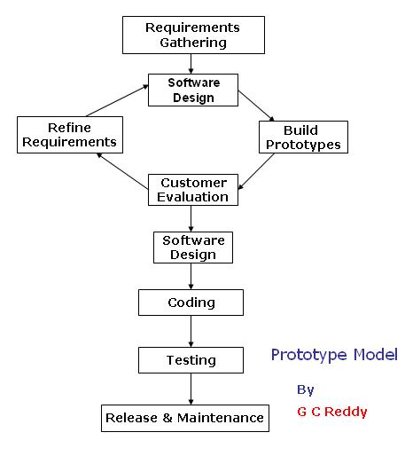
Prototype Model Diagram
Advantages of Prototype Model:
o The customer doesn’t need to wait long as in the Linear Model or Waterfall Model.
o Feedback from customer is received periodically and the changes don’t come as a last minute surprise.
o Customer’s interaction improves the Quality as well success rate.
Disadvantages of Prototype Model:
o It is an expensive approach and time taking process when its compare to sequential models like Waterfall model.
o Customer could believe the prototype as the working version.
o Developer also could make the implementation compromises.
o Once Requirements finalized then adopting changes in Requirements and adding New Requirements are difficult.
->Prototype model
Spiral Model
Spiral model is also known as the spiral lifecycle model. This development of model combines the features of the prototyping model and the waterfall model. In spiral model, we can easily adjust the software development with the required changes. The prototypes which are created in every stage enable us to roll back only a few steps. This model is favored for large, expensive, and complicated projects. It is a circular view of the software lifecycle.
Overview
Spiral model was first defined in an article by Barry Boehm in 1986. This spiral model is based on experience with large government software projects. The goal was to provide a model with greater flexibility that could better serve these types of projects.
Spiral-Model Software Development Life Cycle
In this cycle, each passes through the spiral model consists of Planning, Risk analysis, Engineering, and Evaluation phase.
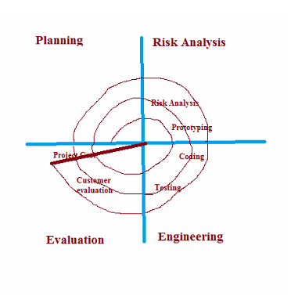
Planning: In this phase, the new system requirements are gathered and defined after a comprehensive system study of the various business processes. This usually involves interviewing internal and external users, preparation of detailed flow diagrams showing the process or processes for which going to be developed, the inputs and outputs in terms of how the data is to be recorded/ entered and the form in which the results are to be presented.
Risk Analysis Phase: In this phase to identify risk and alternate solutions, a process is followed. The process includes addressing the factors that may risk the successful completion of the entire project development including alternative strategies and constraints. The issues pertaining to the possibility of the development if not meeting, for example, user requirements, reporting requirements or the capability of the development team or the compatibility and functionality of the hardware with software. To undertake development, the Risk analysis and suggested solutions to mitigate and eliminate the Risks would thus become a part of the finalized strategy. A prototype is produced at the end of the risk analysis phase.
Engineering Phase: In this phase, software is produced along with coding and testing at the end of the phase. After preparation of prototype tested against benchmarks based on customer expectations and evaluated risks to verify the various aspects of the development. Until customer satisfaction is achieved before development of the next phase of the product, refinements and rectifications of the prototype are undertaken.
Evaluation phase: In this phase, the final system is thoroughly evaluated and tested based on the refined prototype. Evaluation phase allows the customer to evaluate the output of the project to date before the project continues to the next spiral. Routine maintenance is carried out on a continuing basis to prevent large scale failures and to minimize downtime.
Advantages of Spiral Model
• It is a good model for large and complex projects.
• It reduces problems at all levels with direct consideration of risks.
• In this phase, software is produced early in the software life cycle.
Disadvantage of Spiral Model
• It can be a costly model to use.
• When the risk analysis is carried out, it needs highly specific expertise which may not be available all the time.
• The project success is highly dependent on the risk analysis phase.
• It is applicable only to large scale systems and doesn’t work well for smaller projects because of the cost of evaluating risk.

Agile Development Model

Overview:
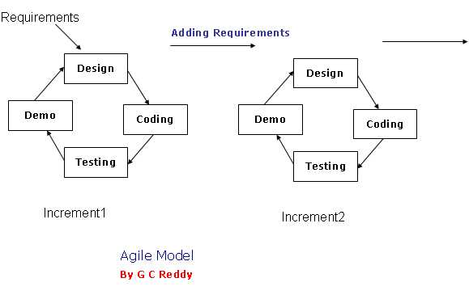

Test Levels
1) Unit/Component/module/program Testing
Component testing searches for defects in, and verifies the functioning of, software (e.g. modules, programs, objects, classes, etc.) that are separately testable.
Component testing may include testing of functionality and specific non-functional characteristics, such as resource-behaviour (e.g. memory leaks) or robustness testing, as well as structural testing (e.g. branch coverage).
One approach to component testing is to prepare and automate test cases before coding. This is called a test-first approach or test-driven development.
b) Integration testing
Integration testing tests interfaces between components, interactions with different parts of a system, such as the operating system, file system, hardware, or interfaces between systems.
Component integration testing tests the interactions between software components and is done after component testing;
System integration testing tests the interactions between different systems and may be done after system testing.
Testing of specific non-functional characteristics (e.g. performance) may be included in integration testing.
c) System testing
System testing is concerned with the behaviour of a whole system/product as defined by the scope of a development project or programme.
In system testing, the test environment should correspond to the final target or production environment as much as possible in order to minimize the risk of environment-specific failures not being found in testing.
System testing may include tests based on risks and/or on requirements specifications, business processes, use cases, or other high level descriptions of system behaviour, interactions with the operating system, and system resources.
System testing should investigate both functional and non-functional requirements of the system.
d) Acceptance testing
Acceptance testing is often the responsibility of the customers or users of a system; other stakeholders may be involved as well.
The goal in acceptance testing is to establish confidence in the system, parts of the system or specific non-functional characteristics of the system
Contract and regulation acceptance testing
Contract acceptance testing is performed against a contract’s acceptance criteria for producing custom-developed software. Acceptance criteria should be defined when the contract is agreed. Regulation acceptance testing is performed against any regulations that must be adhered to, such as governmental, legal or safety regulations.
Alpha and beta (or field) testing
Alpha testing is performed at the developing organization’s site. Beta testing, or field testing, is performed by people at their own locations. Both are performed by potential customers, not the developers of the product.

